

**SOUTHERN UNIVERSITY COLLEGE**

**FACULTY OF COMPUTER SCIENCE**

**CSIS2124 MULTIMEDIA DEVELOPMENT**

**GROUP PROJECT**

**LECTURER: MR. PANG YEE YONG**

|  |  |  |
| --- | --- | --- |
| Student Name | Student ID | Batch No. |
| Be Chi Yan | D180002A | CS18-C |
| Law Bing | D180400C | CS18-C |
| Lee Jia Ming | D180441C | CS18-C |

**Table of contents**

**Instructions** ----------------------------------------------------------------------------------------------------**1**

**Inspirations** ----------------------------------------------------------------------------------------------------**1**

**How to play** ---------------------------------------------------------------------------------------------------**1-2**

**Screenshots** ---------------------------------------------------------------------------------------------------**2-3**

**Notable traits and flaws** -----------------------------------------------------------------------------------**3**

**Conclusion** -----------------------------------------------------------------------------------------------------**3**

**1. Instructions**

This report is about our group project for multimedia development “Flappy Rocket”, which is a group project that was themed “Typing game”.

**2. Inspirations**

Our group project, “Flappy Rocket” is inspired by a simple yet famous game called “Flappy Bird”. The reason why we choose “Flappy Bird” as inspiration not only we like to play the video game which have simple yet addictive gameplay, but its simplicity was also good for practising our coding skills for ActionScript (Flash). At the same time, we also combined the typing game gameplay into our group project, which can let the player improve their flexibility on typing the right letter in the limited time.

**3. How to Play**

The game will start when player press the key with the same letter that was displayed on the screen.

Press the key with the same letter that was displayed on the screen to let the rocket flapped up.

If the player did not press anything or wrong key, the rocket will fall down.

Press the right key to flap the rocket at the right time so the rocket can avoid the obstacles.

The letter on the screen will change whenever an obstacle was avoided.

The more obstacle the rocket avoided, the more score the player got.

If rocket fall out from the screen or hit the obstacles, the player will need to start it over again by the key with the same letter that was displayed on the screen as the score was cleared to 0.

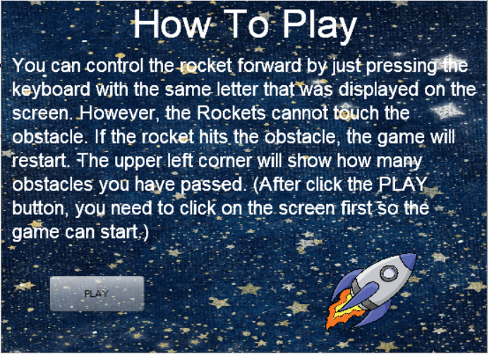

**4. Screenshots**

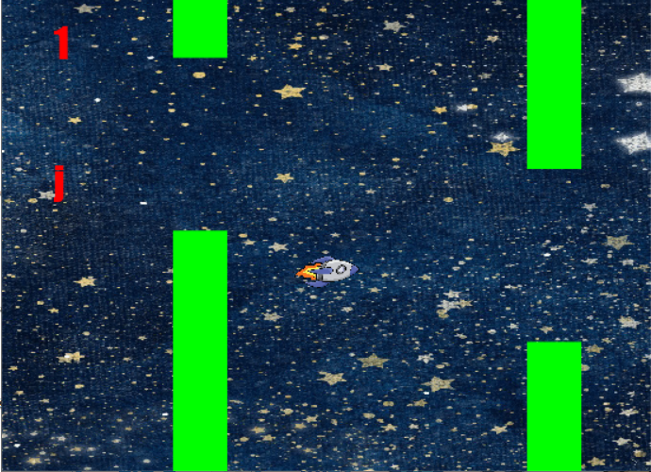

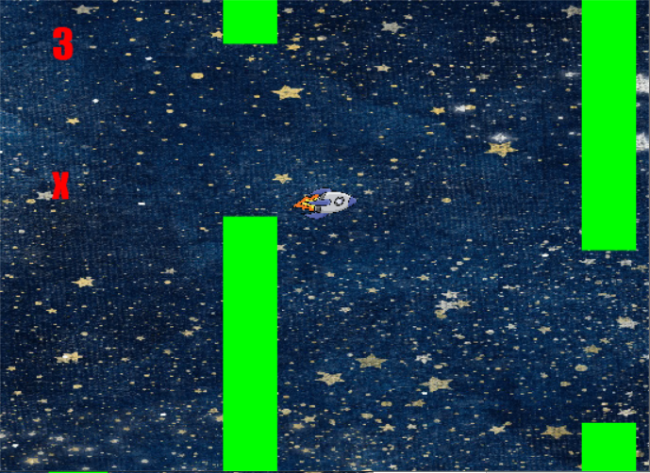

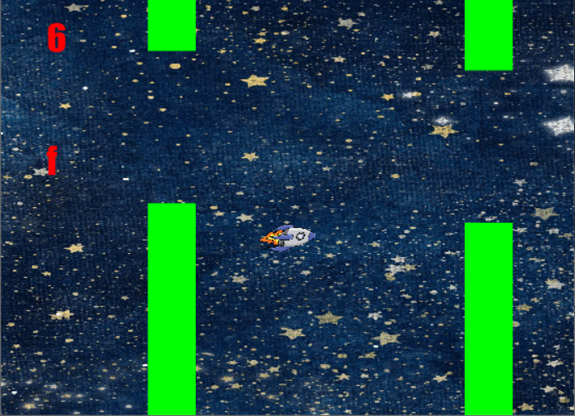

**5. Notable traits and flaws**

**Traits:**

* The combination of typing game and the gameplay of “Flappy Bird” was perfectly recurred with our coding on ActionScript.

**Flaws:**

* Unlike “Flappy Bird”, There is no sound effect when the rocket hit the obstacles.
* There is also no high score and achievement system

**6. Conclusion**

With this group project, we not only learned that programming the flash game is not an easy job, but also improved our understanding about how flash game was coded and programmed. With these understanding and the improvements of our coding skills, we are glad as we can use these experiences for developing bigger, more complicated project at future.